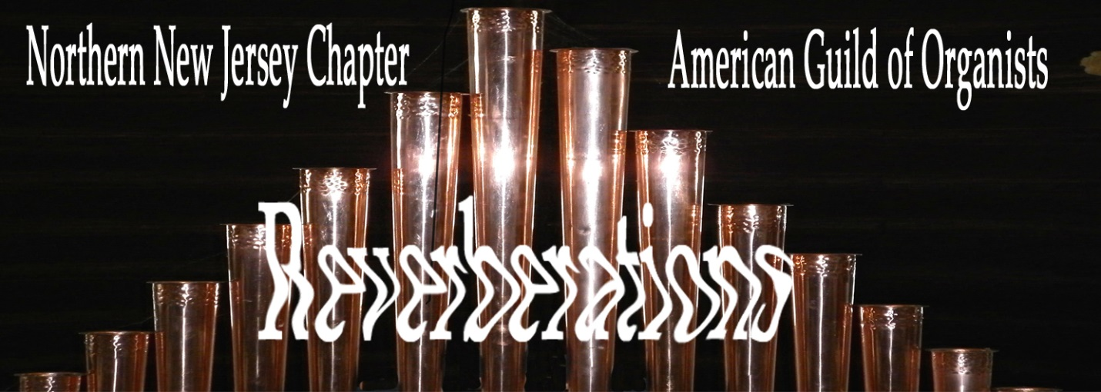
Dear Friends and Colleagues,
The Northern NJ Chapter of the AGO is thriving! Take a look at the programs we’ve had this past year. They’re all focused on helping each of us to be better musicians as we lead music ministries in our churches

Cathie Ruppi, Dean
Visit Our Website: northernnjago.org

AGO PROGRAMS FOR 2018-2019
September Pot Luck/BBQ Gloria Norton’s house 6:00 pm
Kick-off Dinner featuring Just 4 Kicks, Sweet Adeline quartet
October Organists’ Studio with Hector Olivera 9:30 -12:00 pm
West Side Presbyterian Church, Ridgewood
Hector Olivera Recital 3:00 pm
Patron’s Series, West Side Presbyterian Church, Ridgewood
November At Home with PDQ Bach 7:30 pm
St. Andrew’s Episcopal Church, Harrington Park
February President’s Day Conference at St. Thomas 5th Ave, NYC Organ
March An Evening with James Kennerley 7:30 pm
Bethlehem Lutheran Church, Ridgewood
St. Olaf/Rodland Scholarship Recital 3:00 pm
Holden Miller, St. Olaf College 2019
May Registering French Baroque Music 7:30 pm
St. Philip the Apostle Church, Saddle Brook led by David Macfarlane
June Chapter Dinner at Local Restaurant – PentaBash 6:30 pm

Dean: Cathie Ruppi
Sub Dean: June Murano-Murray
Treasurer: David Macfarlane
Secretary: Susan Gadd
Our Leadership Team
Chapter Administrator: Stewart Holmes
Membership Coordinators: Rick Tegtmeyer Bob Wheeler
Newsletter & Web: Stewart Holmes
Historian: Bob Wheeler
Hospitality: Gloria Norton
Past Dean: David Macfarlane
Anita Bontecoe
Class of 2019: Stacie Yao
Class of 2020: Melissa Murray
Class of 2020: Claudia Smith


6 South Monroe Street, Ridgewood
201-652-1966 • www.westside.org
Sunday, February 11 at 3:00 pm

